


Cairo University, Faculty of Computing and AI
CS213: Object Oriented Programming
Assignment 2
Course Instructor
Dr. Mohammad El-Ramly
(S17,S18)

Name | ID | Email
Osama Adel Saad El din | 20242036 | 20242036@stud.fci-cu.edu.eg
Mohamed Ahmed Samir | 20240463 | 20240463@stud.fci-cu.edu.eg
Abdulwahed Hussein Abdulwahed | 20240333 | 20240333@stud.fci-cu.edu.eg
Mohamed Hussein Juma | 20231139 | 20231139@stud.fci-cu.edu.eg

work breakdown table
Name | ID | tasks
Osama Adel Saad El din | 20242036 | 12 (10s forward/backward buttons )  13 (Save & load last session )  14 (Add track markers & jump to them)
Mohamed Ahmed Samir | 20240463 | 4 (Loop audio continuously)  7 (Position slider with time update )  10 (A-B segment looping)
Abdulwahed Hussein Abdulwahed | 20240333 | 3 (Mute/Unmute)  6 (Speed slider (fast/slow))  9 (Progress bar OR waveform with pointer)
Mohamed Hussein Juma | 20231139 | 2 (Add play/pause + go to start/end)  5 (Display metadata (title, author, duration))  8 (Playlist support)

Description of the chapters I created
- Player Audio Class
The PlayerAudio class is responsible for handling all audio processing in the application, including playback, volume control, speed adjustment, looping, A-B segment replay, and track markers.
- Attributes
- Transport Source → Controls audio playback.
- Reader Source → Reads audio files.
- resampler → Controls playback speed.
- Speed Ratio → Stores speed multiplier.
- looping → Enables/disables looping.
- markers → Stores timestamp markers.
- Point A, point B → Stores timestamp markers.
- muted, prevGain → Used for mute/unmute feature.

- Main Methods
- Play, pause, stop, restart.
- Toggle Mute.
- setPosition, skip Seconds.
- Set Speed.
- Set Looping.
- Set A B Points, clear A B.
- Add Marker, jump To Marker.

- PlayerGUI Class
The PlayerGUI class manages the graphical user interface (GUI) and handles user interactions. It contains buttons, sliders, playlist view, and marker selector.

- GUI Components:

Control buttons such as: Play, Pause, Stop, Loop, Mute, 10s Forward/Backward, A, B, Add Marker
Sliders for:
- Playback position
- Volume control
- Speed control
- Combo Box for selecting track markers
- List Box for playlist display

Key Methods:

- Button Clicked() → Handles button actions.
- Slider Value Changed() → Detects slider updates
- Timer Callback() → Refreshes UI during playback.
- Calls PlayerAudio functions to execute audio tasks (Association relationship).

3. Main Component Class

The Main Component class is the core of the application. It initializes audio, manages the GUI, and handles saving/loading user session data.

Core Responsibilities:

- Controls audio processing via PlayerAudio
- Displays the interface using PlayerGUI
- Saves and restores the last playback session
- Manages JUCE audio callbacks

Inheritance:

- Main Component : public
- Audio App Component, public
- PlayerGUI::Session Listener

This means it inherits:

- Audio App Component to process audio streams
- SessionListener to handle session save/load action

Key Methods:

- Prepare To Play
- Get Next Audio Block
- Release Resources
- Save Session Request
- Load Session Request

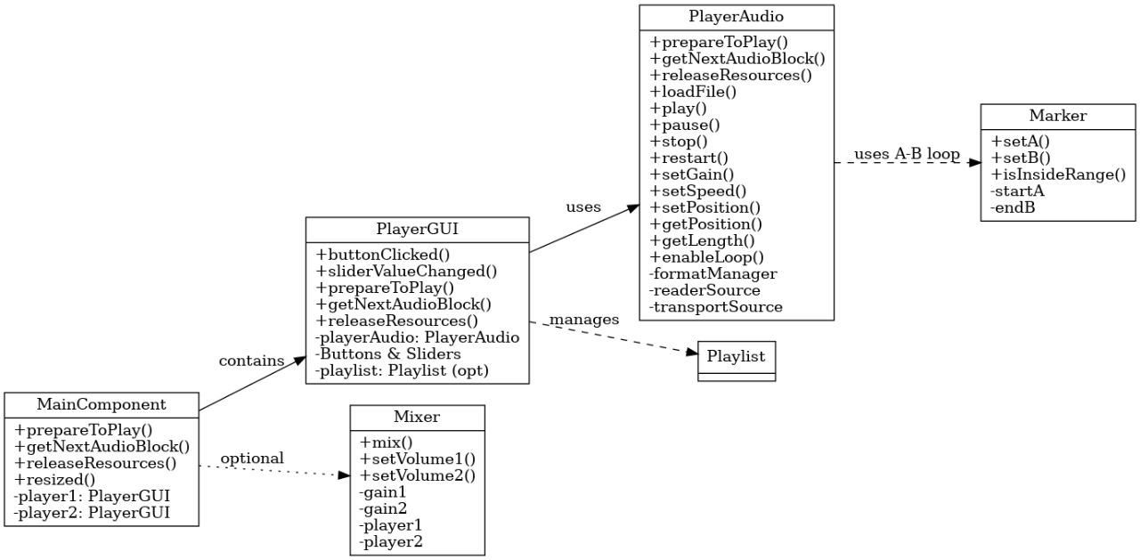

A description of how you use object-oriented programming principles.

1) التغليف — Encapsulation

Hiding internal details (data/state) within the object and providing a public interface (public methods) for dealing with them.

It hides internal states such as
- transportSource
- readerSource
- marker
- pointA/pointB
- muted and displays a clean global interface: play
- pause
- loadURL
- setPosition
- get Position
- getMarkers

PlayerAudio

In PlayerGUI, most interface elements
- buttons
- sliders
- labels
- playlists
- a Set/b Sets

PlayerGUI

استخدام std::unique_ptr<juce::Properties File> في Main Component للتحكم بالملكية/التحرير (ownership encapsulation) ومنع نسخ الموارد.

2) Abstraction

A tidy interface
PlayerAudio And an abstract (logical) approach to dealing with sound: all interactions (formatManager, resampler, transportSource, Audio Format ReaderSource، التعامل مع looping و markers) مُجردة داخل PlayerAudio Main Component و PlayerGUI)

- Player . play(),
- Player. setPosition
- player .get Next Audio Block

PlayerAudio

PlayerGUI::Session Listener هو واجهة مجردة (abstract interface) تقدم عملية مجردة لحفظ/تحميل الجلسة (save Session Request(), load Session Request()) بدون إظهار كيف تتم؛ Main Component يطبّق الواجهة ويقدّم التنفيذ الفعلي. وجود الـ interface هذا يفصل بين واجهة الـ GUI وتنفيذ الحفظ/التحميل.
نقطة مهمة: وجود Session Listener يعزّز فصل المسؤوليات (Separation of Concerns) — GUI يبقى مسئول عن التفاعل، وMain Component مسئول عن حفظ الحالة فعليًا.

3 (Inheritance
Categories that inherit behavior/attitude from another category

PlayerGUI: public juce::Component, private juce::Button::Listener, private juce::Slider::Listener, private juce::Timer, private juce::ListBox Model. Inherits and uses a large set of PlayerGUI interfaces here
JUCE to inherit GUI behaviors (component rendering, event callbacks, timer callbacks, list box model).
PlayerGUI
Main Component: public juce::Audio App Component, public

PlayerGUI::Session Listener - Inherits from Audio App Component to be a ready-made

audio source and implements the session save interface. Download
Main Component

Enhanced Player App : public juce::JUCEA pplication وداخلها MainWindow : public

Main Component

Behavior like - (JUCE(framework) Note: Inheritance here is mainly used to exploit the paint() resized() .get Next Audio Block construct)( is acquired via inheritance from the base classes.

4) التعدد الشكلي — Polymorphism

And it saves the base class the idea: the ability to call functions via interfaces pointers to the derived class (binding at runtime or overrides)

virtual overridesvirtual overrides

- PlayerGUI
- paint
- resized
- button Clicked
- slider Value Changed,
- Timer Callback,
- List Box Model
- Get Num Rows
- Paint List Box Item,
- Selected Rows Changed

PlayerGUI
- Main Component defines prepare To Play
- Get Next Audio Block
- Release Resources
- overrides of

juce::Audio App Component/Audio Source - Java-style runtime by calling these functions at runtime. Framework allows polymorphism.

: At runtime binding, use a pointer interface to work

PlayerGUI holds a Session Listener pointer and can call session Listener->save Session Request() or load Session Request()() without needing a listener ( gui .set Session Listener(this()). Thus, when the GUI requests, it sets the Main Component to know which actual class the interface saves from—in your project, it saves. This is a powerful example of Main Component saving the executed session via a polymorphism pointer interface.

MainWindow::close Button Pressed (uses)
Dynamic _ cast <Main Component< on get Content Component (then calls)
main->save Session Request)( - This step uses polymorphism and RTTI
to confirm the content type before calling

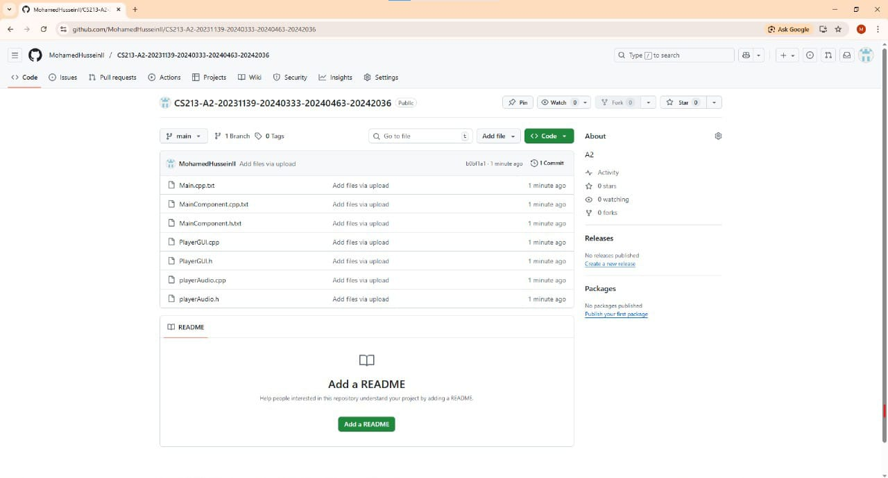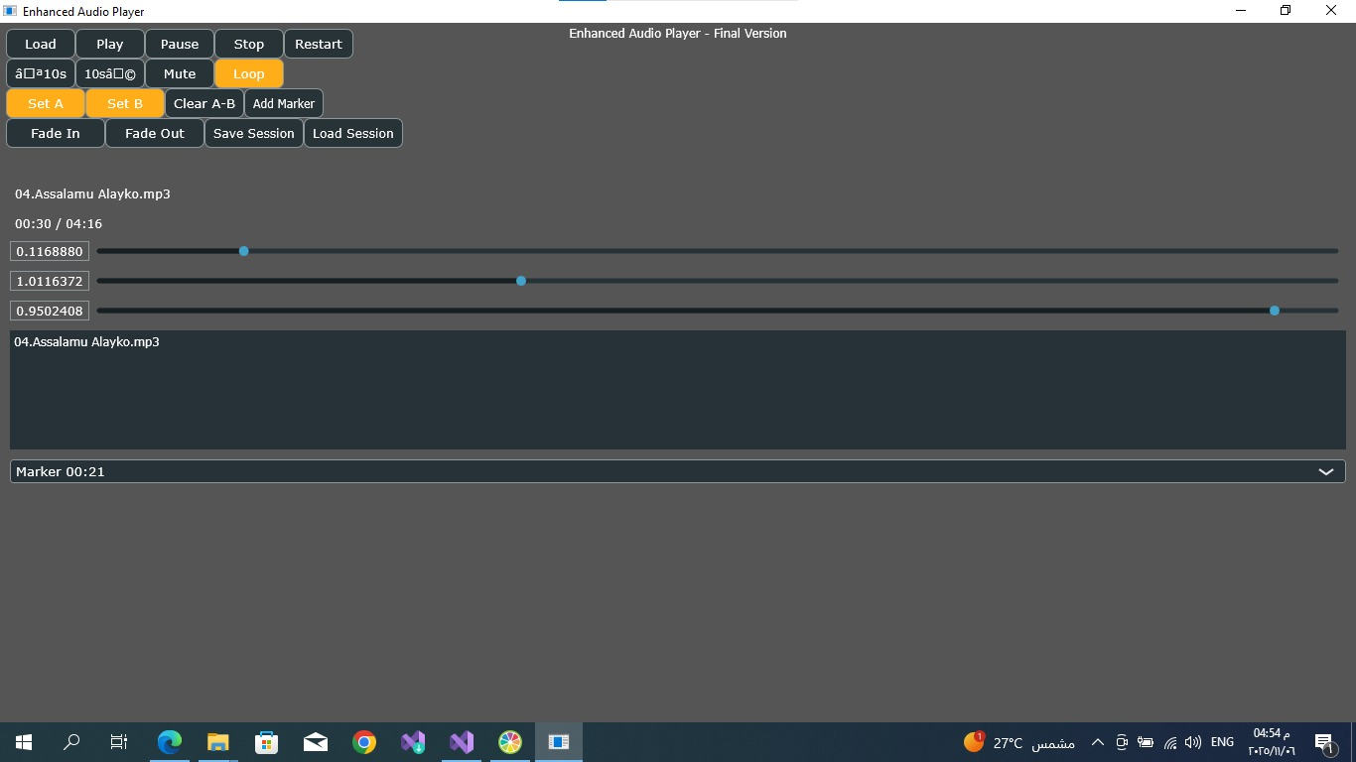

Link gith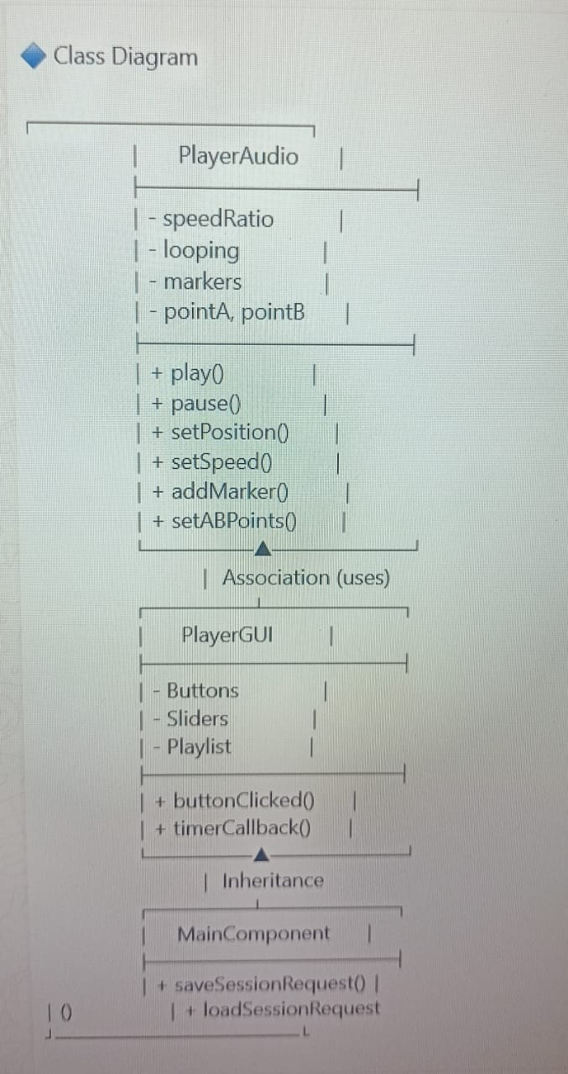ub
Link Video

